- Even with perfect heuristic, need to cover all opponents move choices and this will not be sufficient to find a single path to goal
- Knowledge in heuristic search:
  - State and move evaluation
  - Search depth
  - Time control
- State evaluation
  - Mapping from a full state to one number
  - It measures how good that state is
  - Same thing as position evaluation/evaluation function
  - We know exact value in terminal states
  - Heuristic evaluation
    - Higher is better and is just a number. Could be estimate of game score
    - Decision making, order given by numbers only matter
      - Decides preference or ranking between moves
    - Leaf nodes of search evaluated
      - Heuristic evaluation of non-terminal states
      - Exact evaluation for terminal states
    - Interior nodes in search evaluated by minimax in which we go back up to parent all the way to root
    - A monotonically increasing function x>y f(x)>f(y)
    - Cardinal comparisons become important when you aggregate multiple evaluations
      - Some increasing mappings given same search behaviour when evaluations aggregated
    - All states with same evaluation are equally good and have same P(Win)
    - An evaluation function partitions set of all states S s.t.
      - Subsets S_v in which it is one subset for value v and all states in the same S_v are assumed equally good
    - If we are careful, using an exact and heuristic evaluation can allow us to get true proofs and losses. Importance of good heuristic a it speeds up exact proof
  - Winning probability
    - As above higher is better
    - Has interpolation as probability
    - Minimax score
    - No probabilities in game itself, perfect player would know with certainty
    - Machine learning used to learn estimates of win probabilities
- Move evaluation:
  - Mapping from an action/move to a number
  - Measure how good that current move is
  - Can be used to filter out moves
  - Also known as action/move value or Q-value
  - Given state and possible moves from states, put numeric value on each move
  - Can include/not include probabilistic interpretation
  - 2 interpretations involving move I given probability p_i
    - P_i =P(win) or P_i =P(best move) for move I
- If we have state evaluation but need move evaluation
  - Evaluate state after move
  - Can be slow if large branching factor
- If we have move evaluation and need state evaluation
  - Slow noisy result is to perform a greedy rollout followed by sequence of best evaluated moves and we still need to evaluate terminal state to get value
  - Random simulations are better
- We get evaluation knowledge from Machine learning techniques
  - Hardcoded rules
  - Simple features
    - Each feature is a Boolean statement about state/move and are easy to compute
    - Can construct evaluation function from this

  - Pattern databases
    - If we frequently use patterns from master games, we can learn them
    - Measure how often center move is played immediately or later
  - Neural nets
    - Knowledge= weights in neural net
    - Lower level encode local knowledge while higher levels express global evaluation
- Benson’s alg finds stones/territories which are unconditionally alive in that opponent can never capture stone no matter their play
- Monte Carlo Simulations main idea is to learn info from random sequences of decision steps
- Can be used for numerical integration
  - Very general
  - No assumptions on type of function to integrate and can also be used in higher dims
  - Need bounding box with object random point generator and a fast method to check if point is inside/outside object
  - High variance and slow convergence
  - Faster methods exist
- Monte Carlo came from Manhattan Project in 1940s by Ulam and von Neumann
- Markov Chain Monte Carlo
  - Simulate Random walks of paricles in which the walk is biased from physis constrains and the particle distribution is close to true distribution of what is measured
  - Used in image rendering by path tracing
- We need a model to able to simulate anything
- Garbage in Garbage out, simulation only good as model
- Given a Boolean formula, we assign true and false to the variables in such a way that make the formula true. Hence it is called satisfiable. Usually use heuristic search
- Note Boolean satisfactory Problem is abbreviated to SAT
- Systematic SAT solver:
  - Given n variables in formula
  - Set x_0 to True and solve for remaining formula and if fails, set x_0 to False
  - 2^n variable asssignments and exponential in n so could take a very long time to solve if not lucky
- Biased Random Walk(1990s):
  - We randomly assign T/F to variables and then use heuristics to flip one variable if not true. Restart if no progress
  - Exploitation: Flip variable which makes largest improvement while Exploration is just flipping a random variable
- Backgammon simulation:
  - Rollout games with different dice trhow sequences and play most successful
- Using random simulations for chance games is natural but without chance, its less natural and took a while to develop said methods
- TicTacToe simulate
  - End when board is full or three in row
  - 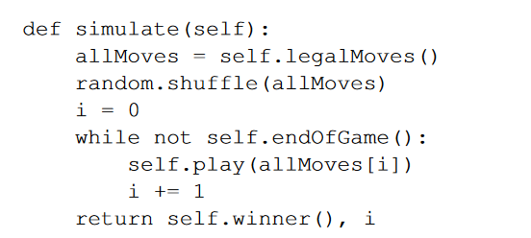
- To see if a game state is good:
  - Compute minimax value or run the solver
  - We also run simulations and score final result then get the win rate over all simulations
- A simulation based player uses 1-step lookahead to evaluate moves and for each move it will run n simulations and measure is winrate. Known as Flat Monte Carlo called so due to having a shallow tree
- Monte Carlo Method uses random simulations
- 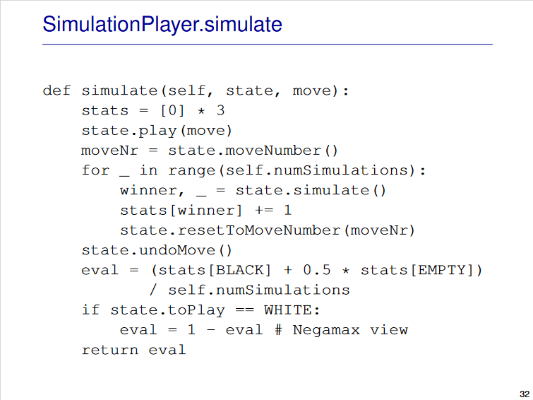
- 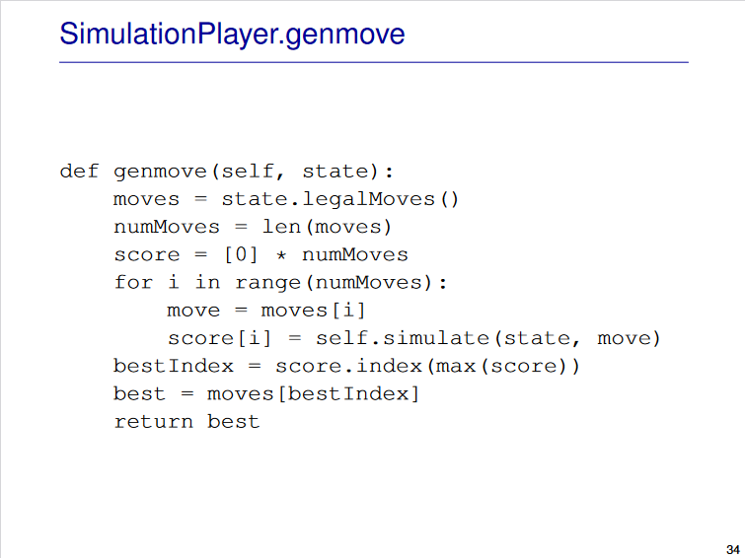
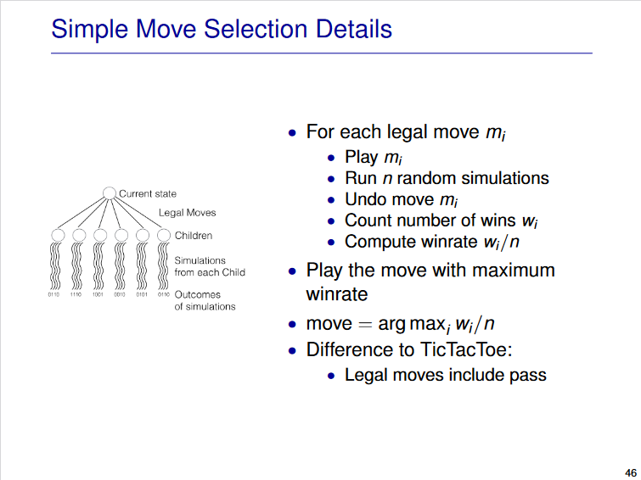

- Strength of Go3:
  - May simple tactics
  - Finds sure win near end
  - Avoid blunders random player may play
  - Up to a limit, as no of simulations increase, improves
- Weakness:
  - Assumes opponent is random as plays move best against random
- Ideal simulation preserves winds and losses exactly
  - If start pos is win/losssimulation is also win/losss
  - Implies every simulation is a perfect game with a perfect evaluation function
- Evaluation is the mean outcome of solutions which is the sum of simulation outcome/number of simulations
- Variance is the sum(simulation outcome-mean)^2 divided by the num of simulation
- An idea playout means we have a variance of 0 and thus mean=min_max score
- Real playout: means variance is greater than 0 and thus mean is not minmax score
- Bias is minmax score-mean
- MoGo= Monte Carlo Go Programs
  - Uses UCT and improved playout policy by tactical3x3 patterns
- Filter is what decided whether should be used or not
  - 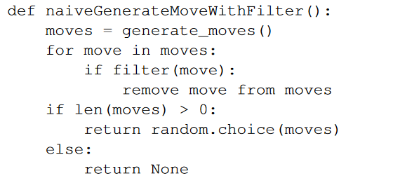
  - 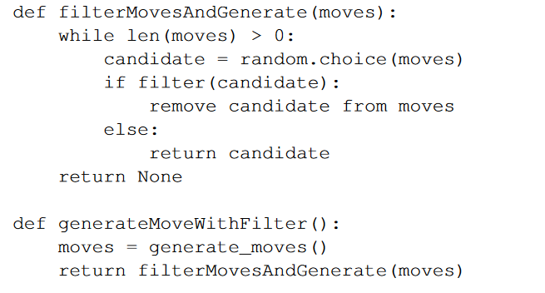
  - Moves would be in a list/array
  - To remove move at index I its to set I index to last element and pop
- Be in Atari-1 liberty
- Give Atari reduces opponents liberty to 1
- Selfatari is reduce ones own liberty to 1
  - 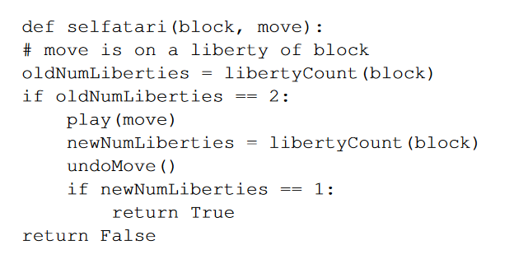
- Use both rules and filters to generate good moves
- 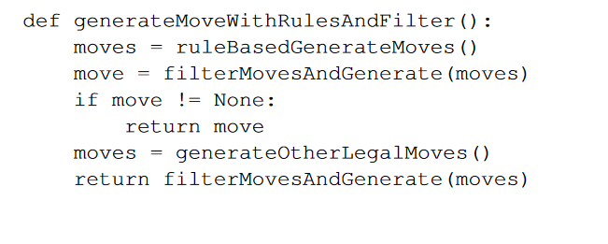
- Another way is to look at small loca area of move and decide if moves are good/bad based of stone pattern
- 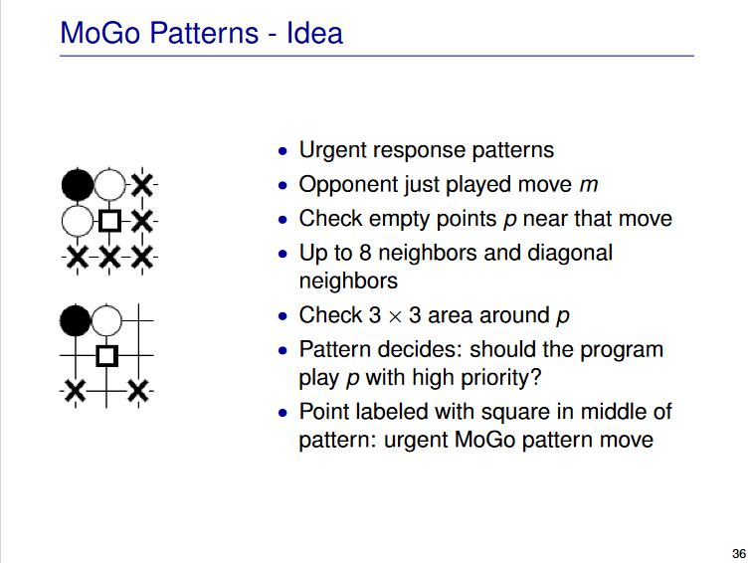
- 4 operations lead to symmetry with 16 different combinations
  - 2 rotations
  - 2 vertical flips
  - 2 horizontal flips
  - 2 colours swapping
- Wildcards match more than one game state(empty/B/W/Off board)
- Simulations must be stochastic or explore different sequences
- Variety in simulations is important as we got more information about state space
- Through randomness, we average out randomness
  - If no bias
- More samples= lower variance
- Recall policy types
  - Uniform random in which all legal moves are likely
  - Rule based in which all moves from a list are likely
- Probabilistic probability:
  - Play moves based off a probability
  - All probabilities sum to one
  - N legal moves for a position
  - Move I is chose with p_i
  - Use a heuristic to allow better moves to be more likely played and filter out bad probability moves
  - Uniform and rule based can be seen as this
- Heat map: red/orange are high probability, green is ok while blue is bad
- We don’t need many simulation too see a move is better than another thus we focus on higher % moves. Main idea of UCB
- Law of Large Numbers: Repeating an experiment multiple times gets results closer to expectation
  - As number of experiments(n) approaches infinity, the empirical frequency approaches p for an event E
- Bernoulli Dist: Random variable with 2 different values(only 2 outcomes)
  - P(X=0)=1-p and for P(X=1)=p given a fixed probability p
  - A Bernoulli Experiment is repeated many times for a fixed o and will draw from the distribution for p.
  - 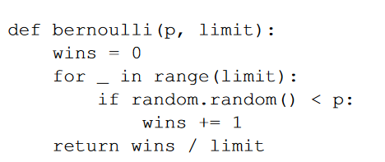
- Sampling from a game tree is a Bernoulli Experiment
  - Each leaf only has 1 or 0
  - Finite tree, leaves and paths to leaves
  - Fixed dist over children for simulation policy per node
- When we increase simulation number, winrate for child will stabilize due to law of large numbers, but if we do an infinite number of simulations, we will approach true winrate but can be fair from true minmax value
- More simulation +:
  - Lower variance
  - Better move selection when several moves are tied for first and rule out unlucky cases such as a Bad move winning may simulations or the opposite
- If we repeat a Bernoulli exp multiple times, win no is binomially distributed. Stored as B(n,p) in which is number of wins in n tries where each has a win probability p. To get expected value, n*p. As n increases, B(n,p)/n becomes centered around p
- Confidence interval is a range in which the true value is estimated to be in and a confidence level is the probability that the range contains true value
  - Low confidence level= more chance for error and smaller interval
  - High confidence level, larger interval and less chance for error to occur
- Separation: Whole confidence interval for best move is above all intervals of other moves
  - Aim here is to separate best move from others
  - Takes too long hence UCB which uses upper bound
- Bandit Problem: Run many simulations for each move and choose highest winrate move
  - Using Casino arms as an example, play each arm a select number then select based off results. Can leas to mistakes
- To measure mistakes we can do the following:
  - Use probability of making wrong choice
    - Arm I has best winrate p_i but we choose arm j with p_j<p_i
  - Simple regret
    - Simple regret is p_i – p_j in which j is out move and I is best choice, 0 if we chose best move
    - Each arm pull costs money
    - Used in most simulations
  - Cumulative regret
    - Sum of simple regret
    - Each pull costs something
    - UCB aims to minimize this
- UCB allocates simulations to moves smartly
- UCB(Upper confidence bound) Notations:
  - n_i number of times move I has been tried
  - Total sumlation number N=sum(n_i)
  - W_i: is number of wins for move I among n_i tries
  - Empirical winrate (mu_i)=w_i/n_i
  - Aim is to select best of k moves m_i in range 0<=i<=k-1
  - C is exploration constant and a larger C will require a larger confidence level
- UCB Formula+Loop:
  - 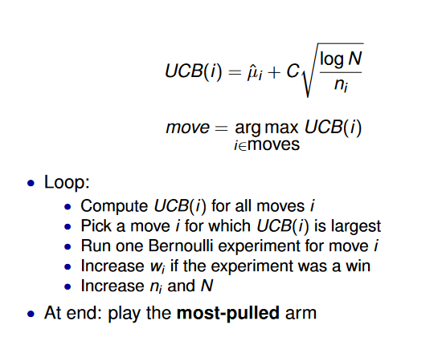
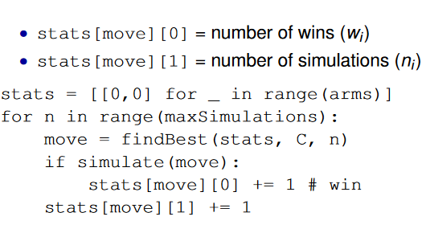
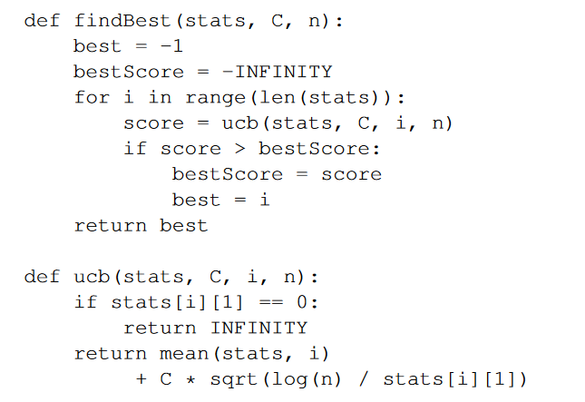
  - Note: if n_i=0 at beginning, to avoid div by zero, we can simulate each move once at start or return inf
  - To choose C, we can either tune for best result or we can use later theories to decide safe choice
  - To exit loop, we either use a fixed limit on total simulation number, stop at high confidence move or there is a single best move, it will have a high % of all simulations
- UCB vs Simple Simulation
  - UCB is more efficient and will quickly focus on small num of promising moves
  - UCB doesn’t stop exploring other moves due to log N
  - Only attempts bad moves rarely
- mu_i is the exploitation and thus prefer moves with high winrate
- Exploration: 1/n_i term prefer moves with large uncertainty, small n_i and log N term will never stop exploring, try bad moves eventually
- We can adjust C to deal with exploration/exploitation trade-off
- UCB is still only 1 ply deep
- Recall Negamax/Naïve Minimax
  - Explores full game tree and all children searched
  - Min over children at min nodes and max at max nodes
  - Exact and terminal nodes are true end of game
  - Uses only exact scores at termina modes for evaluation
- Recall efficient minimaxBoolean minimax/alphabeta:
  - Parts of tree are cut by pruning
  - Visit only one child for winner else try all moves for loser
  - Backup values are upper and lower bounds and not exact values
  - Exact
- Recall Depth-limited alphabeta:
  - Same as alpha beta but limited depth
  - Min and max values act as backups
  - Selective in that we perform herisitc evaluation at terminal nodes despite the search process being exact
- O(b^d/2) is too much even as best case so we perform selective searches by reducing both b and d till search is in budget
- Selective alphabeta search:
  - Depth limited and doesn’t consider all legal moves
  - Backs up result min and max
  - Its selective
  - Heurisitc evaluation at terminal nodes
  - Skips some legal moves
  - Source of error : Heuristic evaluation in leaf nodes and could also prune best move
- If we repeatedly sample in Simulation player:
  - We only sample moves close to start which doesn’t improve branching factor lower in tree with a small ssample number
  - We can eventually sample all nodes in full tree infinitely often or some subtree infinitely often when using a selective policy for large sample number
- Uniform random simulation policy:
  - Visits all nodes and only takes amx at root while averaging all simulations
  - Its selective but not exact due to averaging
  - Average can be far from min/max and large uncertainty with small sample
- Non-Uniform simulation policy:
  - All nodes except subtree below nonselected moves
  - Same as above
  - Selective
  - Avergae over better samples is closer to min/max
- MCTS(Monte Carlo Tree search):
  - Visits tree at start then simulations to finish
  - Takes weighted average over children whose weiht is no of simulations
  - Close to min/max if high weight
  - Selective
  - Deeper search for better moves
  - Converges to exact with time
- Using MCTS and UCT:
  - We add selective tree search
  - UCT adapts UCB to work on trees
  - Simulation is ruin from leaf of tree for evaluation
- MCTS:
  - Select: traverse existin tree using UCT to select child node
  - Expand: Add node to tree
  - Simulate: Follow simulation policy to end of game
  - Backpropogate: Update winrate along path to tree
  - Alg: 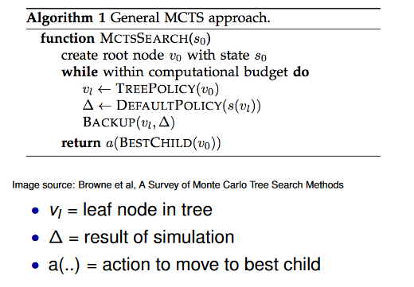
- MCTS Tree traversal:
  - Start from root
  - Go to best child and repeat till we reach leaf node using UCT
- UCT aims to balance focus on promising moves with focusing on moves where uncertainty about evaluation is high
- 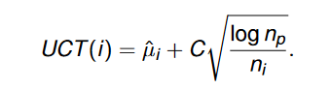 where n_p is simulation count of parent but exactly the same as UCT at root
- To grow tree we can add one node per iteration or from current simulation
- For MCTS simulation:
  - Use any sim policy
  - Run simulation from leaf node of tree
  - 1 or 0 is sim result
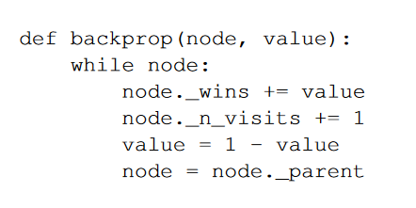
  - 1- Value switches from loss to win and win to loss
- Max child: highest num of wins
- Robust child: Select most visited root child
- While it can expand on best win rate, can explore inferior move
- Low sim count and high uncertainty could be selected
- Can use max robust child to help prevent above
  - Idea is if a move appears to be good, add more simulations to stabilize winrate but if fluke, confidence bound and winrate drop
- Machine Learning: The idea of letting a system learn from data, independently and data to data without being explicitly being programmed to do so
  - We can use this to learn from an evaluation function or a move generation policy
- Transposition table is an example of remembering facts
- Supervised learning: learning from labeled training data and is labeled with correct result
- Unsupervised: Unlabeled training data
- Reinforcement: Interact with environment and learn from rewards
- Semi Supervised learning: small amount of labeled and unlabeled training data
- Learning with a model allows us to try out actions and observe results in a simulator whereas learning from a experience allows us to learn from observations of the effect of real actions
- Given training data points, aim is to learn a function which maps x to y and ue it for prediction
- Training an test data must be independent
  - Split 90/10
- Overfitting occurs when u learn the noise as well as data, thus isn’t a good model for unseen data
- Underfitting is when we cant see th regularity in data from learned function
- Linear regression: y=ax+b in which a and b are the params to optimize which we use least squares to solve
  - We use square error to find difference y_i and ax_i+b as easier to optimize and also penalizes large errors
  - Square error is (y_i – (ax_i+b))^2 then we sum for all I values
- Input representation:
  - Raw input which I location of stones on the board/sequences of moves
  - Features which help learning such as liberties, patterns and proximity to last move and selfatari
- Model representation:
  - Simple to prevent overfitting but complex as needed to represent what we need
  - Functions which we have efficient learning algs and functions which represent general assumptions
- To develop model:
  - Create datadevelop modellearn weightsevaluate modelfind problems of data/model then repeat
- Output can be a good/bad move, filter/don’t for search or move evaluation/prob. We can also learn the state position/evaluation or local evaluation
- Feature is a Boolean valued statement about a move where 1 -true/active and 0 is false/inactive
  - G04/5 have a small set of active features
  - Passing and tactics also count as features
- Distance between points: Subtract x1 and x2 then do the same for y. Must be absolute
  - Distance metric is dx+dy +max(dx,dy) where d=distance of
  - Measure between last played move, prev stone or line in board
- To evaluate features in move, we sum the product of the weight and feature whereas Coulum thinks its product of active weights alone
- Use features for move prediction
  - Fast ones use simple features only but slower accurate ones use deep neural networks
- Feature learning: Get training/test data(From pro, amateur or computer program)label each move in pos by filterLearn feature weights-use to select good moves
- Treat move prediction as a classification problem in which we have 2 classes(highest scoring move and all other moves) and ends when m*(move played my master) is highest
- Features representing master move>only other feature group
- Tabular learning memorizes which moves were good in positions so no generalization whereas feature learning tells us which features are good/bad and allows generalization for moves not seen b4
- Higher weight, better feature
- To compare 2 features, w_i/(w_i+w_j) and see which is higher
- As moves have more than one feature, we combine them by multiplying the weights tog et strength and compare moves strength using above formula
- 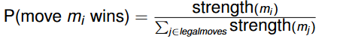
- To find weights for all features s.t. playing master move is max: 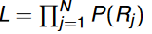 where P(rj) is probability master move is played in test case j
- Since tough directly max L, we instead try to minorize L using m as m(x)<L(x) and can approximate L.
- Minorization-Maximization Alg:
  - Log L is a sum of simpler log terms and for x close to 1, lox s around x-1 and thus 1-x minorizes -Log x
  - 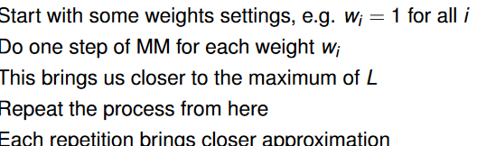
- We can learn probabilities using strength of weights(learned from MM alg) then choose move in proportion to strength
- Can use combinations to learn the number of interactions for k features in relation ot n features(no interpretation as probabilities
- When learning from game records:
  - Can only learn from data and what is represented by model
- Move prediction cant reach 100% prediction due to multiple good moves and what defines best move
  - Symmetry, same endpoint value in endgame, forcing moves
  - Any move which preserves win is equally good
  - Aim to max(p(win))
- At first win rate is noisy so we need knowledge to help guide search but then we must slowly phase out knowledge with more simulations thus we add a value to UCT formula s,t 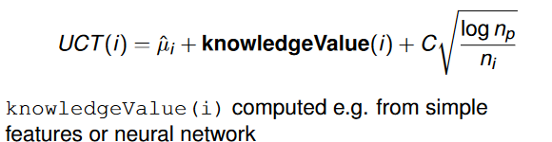 and this must decay over time
- Or we can multiply UCT by p_i which is the p(m_i=best move)
- Neural Networks takes inputs and weight params to produce output y. Can be supervised or reinforcement for NN
  - Used as function approximator
  - Neuron is a math function
  - Each connection between neuron has weight which expresses strength of connection
- A binary classifier has 2 features only and outputs class using w1x1+w2x2+b which is bias term
- Weighted sum of inputs is the sum of the product of weights*input then its passed into a nonlinear activation function for output
- For supervised:
  - X and y are vectors of numbers
  - Compute error between known y and predicted y
  - Gradient descent is when we adjust weights to reduce error
- Functions in neural network
  - Sigmoid: non-linear, grows from 0 to 1. Sigmoid(x)=1/(1+e^(-x))
  - Relu
- Aim is to reduce sum of square errors which is 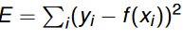
- If we decrease/increase weights, we can reduce error
- Error function is function of simple output from last layer of output
- 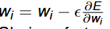 where epsilon I step size, step size if important and if it doesn’t improve with each backprop step, we stop training
- One hidden layer can approximate any continuous function but not necessarily well and doesn’t work for discontinuous jumps
- 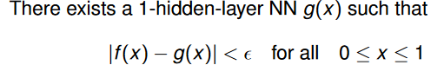
- FC NN is when each neuron on layer n connected to each neuron in next layer and sparse means only connected to some neurons (Convolutional NNs)
- Standard network architecture:
  - Input layer A0 then we go to hidden layers Z1,A1 has 9 neurons to represent board
    - Act as one layer
    - Z deals with weighted sum while A acts as the activation
  - Similar layers to above
  - Then we get the output layer which returns Nx3
- Gradient descent deals with a forward and backwards pass on dataset but is very expensive and can be trapped in local min
  - Stochastic Gradient Descent prevents this by randomly selecting sample but needs more iterations
    - If we use a mini batch however, we shuffle dataset and then divide into batches and train in each batch
- CNNs are useful fr image processing an are sparse connections. Neurons depend on filters (usually 3x3 or 5x5)
  - Determines what features are itself
  - Shares weights across neurons
    - Due to this, we can learn only a single feature so we use several copies of layer called a feature map
  - Neuron o same level computes same function but different input variables and filters
- High level features from simple local features
- Go trained on 19x19 board
- Different Inputs:
  - 19x19x3 (raw input), BW and point forbidden by ko
  - Input with liberty info: splits black, white into 3 separate channels by liberty count
- DCNN:
  - Many small convo layers and zero padding
  - Uses Relu activation(rectified linear unit) and is non linear.
    - F(x)=max(0,x)
    - Derivate is 9 for x<0 and a 1 for x>0
  - Doesn’t backpropogate illegal moves via masked training
  - Edge encoding adds an extra channel for edge of board
  - To train:
    - 88% train, 8% test and rest validation
    - Basic gradient descent and initializes weights randomly from normal dist using mean=0 and s.d=0.001
    - Acc= Equal to master move?
    - Prob= What p did net assign master move
  - Many good moves but not good enough for Go(10 per game)
- Maddison et al
  - 12 layers with Relu
  - 36 input planes
  - 64193 filters per layer
  - Stochastic grad
- RL(reinforced learning)
  - Observe state at time t and produce an action/move then observe reward at next time step
  - Must solve credit assignment problem->No direct for each single move so how can we tell if moves are good or bad
  - Mostly solves single agent(player) problem but there is usually another player
- Supervised Learning
  - Label for each move and aim is to minimize prediction error over dataset
- Value based reinforcement learning uses the following
- 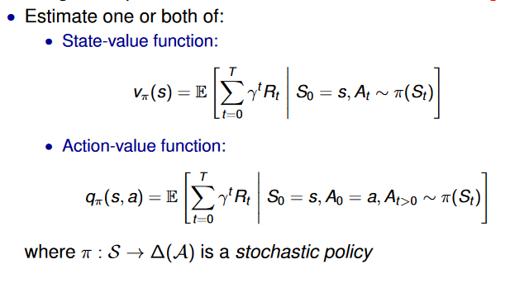
- To construct a new policy to solve credit assignment problem
  - Initalize a set pi(s) for all s In States
  - Policy evaluation computes the estimate V(s) for state values
  - Policy improvement is when the new policy chooses action with highest V
  - Stop if stable(chooses same actions as old one) else repeat step 2 with new policy
- Temporal Difference(TD):
  - Learns prediction from action sequences and rewards only
  - Samples environment
  - Lambda is the discount factor for future rewards
  - Bootstrapping learns predictions from other predictions
  - In TD(lambda), rewards that are in the future count less than immediate rewards
- Function approximations learns a model of values based of features. Can use MC or TD but can overgeneralize
- Tabular learning can improve some game-playing programs
- Neurogammon has 6 separate networks and has fully connected feed-forward nets
  - Hard to make handmade features
  - Expert games are difficult to collect
- TD Gammon:
  - 198inputs with 8 per point
  - Single hidden layer
  - Uses sigmoid and outputs winning probability of input pos
  - TD(lambda)-0.7 and a learning rate of 0.1
- AlphaGo far surpassed human skill in GO
  - Developed in 2014-2017
- DCNN paper produced around 2015
- Versions:
  - AlphaGoFan 2015
  - AlphaGo Lee 2016
  - Alphago Master 2017
  - Alpha Gi Zero 2017 Oct
  - Alpha Zero 2017/18
- Alphago Fan used MCTS with UCT and used a normal simulation policy and Supervised Learning(SL) policy network
  - Later used a strong RL policy network (learned from self play)
  - Uses a value network in which it learns from labelled game data by strong RL policy
  - Not good at producing a good set of moves
  - 3 big network which has overall same design:
    - SL policy
      - Despite weaker move prediction, gave better set of good moves to search
    - RL policy
    - RL value
  - Training pipeline:
    - SL for rollout policy and SL policy network
      - Strong MCTS
    - RL for RL policy and value networks
      - Learn from self play and adjust weights of net
      - training procedure for policy:
        - Learn weights p for current net
        - Play full game and add +1 for win and -1 for loss only at end
        - Update weight via stoch grad ascent(direction which max(Expected output)
        - 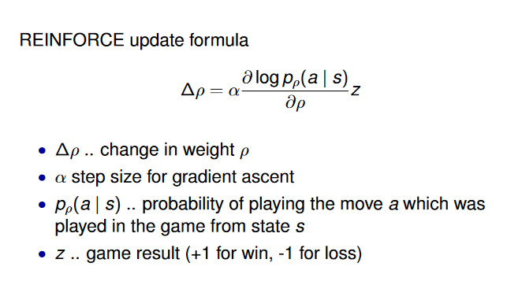
        - Rl policy won 80% vs SL and 85% vs MCST Go
        - No need for search and plays moves by sampling P_p
      - Training for value net:
        - Takes in current state and net weights and returns single num
        - Aim to reduce squared error between value net prediction and true game outcome
        - Uses labeled training data
        - To prevent overfitting, sample one single state from each game
  - Player uses MCT and NN as in-tree knowledge
    - Values stores in edge are win rate Q, visit count N and prior prob P
    - We select move which gives largest Q+u where u is exploration term given by u= C*(P/1+N)) where C is exploration constant
- Rollout policy network
  - Simple and fast
  - Used for MCTS
  - Linear softmax of small pattern features
- Value network is when we learn a state evaluation function from a go position and gives us p(win)
  - Learns mapping from state s to expected outcome of game
- To get the value estimate of a leaf node, we get the weighted average of 2 different evaluations
- Z_L=win/loss result of single simulation from S_L
- V_delta(S_L)= value network evaluation of S_L
- 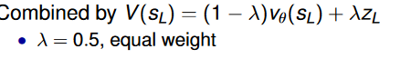
- Elo formula: 1/(1+10^(d/400)) where d id difference
- AlphaGo Lee:
  - Trained from AlphaGo selfplay games
  - Large Neural net
- AlphaGo zero:
  - must know the final outcome of a training game before it learns from it
  - Uses resnets
  - Uses the same input features as AlphaGo but with a different network architecture.
  - Combines policy and value nets into a single net
  - Self learning from pred searched moves+outcomes
  - Hard limit of 19x19x2 moves
  - Uses MCTS but is ised in learning and playing
    - Search improves learning and learning improves search
  - Knowledge from self-play
  - Uses deep residual NN to represent knowledge
    - Policy head learns good moves while value head learns p(win)
    - Passes output of previous block directly through and each block learns the small change to prev output
    - Outputs two values, from position, the first is the p vector of move probavilities for each move a from a state s while the second is the v value of s
    - Policy head: Cross entropy measures how well one probability dist can predict anotherAim to minimize this
    - Value Head: Aims to reduce square error between value v and final result z. Gets p(win)
  - No longer perform simulations till end of game, growth of tree only by NN knowledge
  - Same move selection process: Exploitation term Q and exploration term u
    - Q in this case is the value od simulation ending in-tree state s which s = value head evaluation of s
  - Makes single call to NN and outputs p, vector of move probs for all moves a from s, and the estimated value of s
  - Generates a collection of self play game records va MCTS+NN then samples from this to update NN then compare to old NN
  - Loss= cross entropy+ error of value head + regularization term
  - Run MCTS from state s and check if move a was played N(s,a) times, then (funny looking symbol is proportional) . t controls exploration of low prob moves
  - Divide by N term by sum of action to make into probability
  - Get outcome z and store in a tuple containing current, state, probability distribution derived from visit count of moves in MCTS of s and outcome to be used for learning
  - Sample from above tuple and adjust weights by gradient descent
  - Value of search will remain high
- RL<SL when move prediction due to less human like moves but when it comes to predicting outcome of games
- Residual net over DCNN ad dual net better than separate in all but move prediction
- AlphaGO relies on having perfectmodel of game and must know exact rules, perfect scoring of outcome and full state of game must be known
- Also relies on the many million games created to learn
- AlphaZero:
  - Same 2 head network as in AlphaGo Zero
  - Learns expected outcome and uses board symmetry
  - Continuously updates single network to learn
  - Go chess and shogi
  - Takes advantage of perfect simulator of game dynamics
  - Little game specific knowledge like rules
- MuZero:
  - Learns rules and game representation and only learns from valid game records
  - Use NN to learn model as we search
  - Input is game record with correct moves
  - 3 neural nets:
    - H which maps raw info to internal state representation
    - G learns how to make a move in internal representation and take sin currebt state and action then outputs a representation for next state when playing action a
    - F which computes policy and value from internal representation. Take sin state and outputs (pv) policy and value
  - Search occurs in representation space and usually has a hard coded depth limit
  - Compounding errors if g is called too often
  - Closed source and resource hungry but matches AlphaZero performance
- For perfect info games:
  - Compute minimax
  - Find winning strat which includes a move at or node and all moves and AND nodes
- For imperfect games:
  - No analog minimax value as one players results depends on what all other players do
  - Nash equilibrium important. No single player can profit from changing strategy
  - Mixed strat(choose action according to prob dist)-avoid being predictable
  - Minimax can still exist for 2 players only and achieved by using a mixed strategy
  - We need to reason about players belief
  - Infer opponents card and beliefs via actions
- Cepheus helps solve poker games with a limit on bets
  - Used abstraction to group poker states into state abstract state
  - Learned strat forall 10^14 decision points
  - Used CFR+ for approximation
- DeepStack:
  - Decompose poker computation similar to Go
  - Uses 2 vectors for each player
  - Depth limited forward search was state info
  - At depth limit used a Depp NN
  - One traversal wasn’t enough
  - Uses a standard FC network
  - Vector of values outputted

